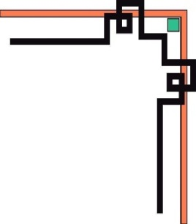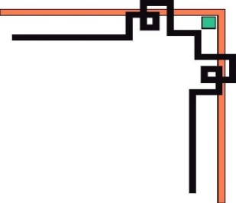

**DANANG SOFTWARE CORPORATION**

**SOFTECH-APTECH**



EProject:

GALAXY Hunter

Guiding faculty: TRINH THI THUY TIEN

Members:

* PHAM PHU DIEN
* NGUYEN SI AN
* LE VAN THANH
* CAO QUANG

Group: 01

Batch: 165

Project Document

**GALAXY Hunter**

|  |  |
| --- | --- |
| **Group 1** | |
| **Instructor** | Mrs.Trinh Thi Thuy Tien |
| **Group Members** | Pham Phu Dien (Leader)  Nguyen Si An  Le Van Thanh  Cao Quang |
| **Batch** | 165 |
| **Semester** | 1 |

**TEACHER’S EVALUATION**

**Table of Contents**

I. ACKNOWLEDGEMENTS 4

II. INTRODUCTION 5

III. PROBLEM DEFINITION 5

1. Homepage 5

2. Planets detail page (Thanh) 6

3. Astronomy news page (An) 6

4. Gallery page (Quang) 6

5. Observatories page 6

6. Contact page 6

7. Search page 7

8. Log in page 7

9. Signup page 7

IV. CRS & SITE MAP 7

1. Customer Requirement Specification (CRS) 7

2. Use case diagram 9

Use Case Specification 10

V. TECHNICAL 21

VI. REFERENCES 22

VIII. CHECK LIST 40

1. Check List of Validation 40

2. Submission Checklist 40

X. PROJECT PLANNING 42

# I. ACKNOWLEDGEMENTS

We would like to sincerely acknowledge the kindness of all the people who have given us moral support and helped us make a successful project.

We wish to express our deep gratitude to the e-Project Team at the Head office, who guided and helped us. Particular thanks to Mrs.Trinh Thi Thuy Tien who suggested the “form validation” and help us connect storage to our project, develop the analysis proceeding from it, and debugging code. We also would like to express our great gratitude to all the student members of our center (Softech Aptech).

Although we have made many attempts, because of the limited time, the practice could not be able to avoid the mistakes and missions. We hope that our project will be considered and evaluated. And finally, we would like to offer many thanks to all our friends for their valuable suggestions and constructive feedback.

# II. INTRODUCTION

Humans have long gazed toward the heavens, searching to put meaning and order to the universe around them. Although the movement of constellations — patterns imprinted on the night sky — were the easiest to track, other celestial events such as eclipses and the motion of planets were also charted and predicted.

Astronomy is the study of the sun, moon, stars, planets, comets, gas, galaxies, gas, dust and other non-Earthly bodies and phenomena.

Galaxy Hunter is a website that will provide brief details about a few facts and details about astronomy such as knowledge about the solar system, detail information of planets, comet, stars, constellation and so on…

Besides, Galaxy Hunter provides information about Big bang theory, the evolution of the Earth, Blackholes, exoplanets, space flight, observatories in the world... Galaxy Hunter not only provides information but also provides an environment like a forum for users can discuss information, that provided on Galaxy Hunter.

# III. PROBLEM DEFINITION

1. **Homepage**

This is the page where the user will be navigated after successful access to the website. Home page gives us a glimpse of distant galaxies, tells us the story of the birth of our solar system.

On the home page, we present brief detail about the universe, planets, galaxy, observatories, and astronomy news.

On each brief detail, the users can see quick view of the information and content. When the users move their cursor over into content, they can click "read more" to read all detailed information about it.

This page also provides a search feature. The users can search for information, which they are interested in. After that, the users can be received the list of results, and they can click on the detailed link to discover information.

Finally, Galaxy Hunter's logo, direct link, log in, signup, and link to the fan page of Facebook, Instagram and Pinterest are display in the footer.

1. **Planets detail page**

The page is divided into two parts. Part 1 provides a brief overview of the solar system planets and dwarf planets and links to part 2 for information about each planet.

Part 2 lags the page with basic information about each planet. Information gives parameters, location, specific features, orbit and axis of rotation, structure, surface, and geology. the page has a referrer to the news site.

1. **Astronomy news page (An)**
2. **Gallery page (Quang)**
3. **Observatories page**

Observatories page provides detailed information of observatories in the world. The users can receive detailed information such as the name of observatories, established year, observatories location. Besides, the users can view the location of the observatory on Google map.

On the observatories page, the user can use the filter feature to show observatories by country.

1. **Contact page**

This page includes the Galaxy Hunter address and its location on google map. The users can send their messages to us through the Contact form.

1. **Search page**

This page provides a search feature. The users can search for information, which they are interested in. After that, the users can be received the list of results, and they can click on the detailed link to discover information

1. **Log in page**

On the login page, the users can log in to the Galaxy Hunter for comments and discuss information, which provides on the astronomy news page with a registered account by username and password.

If the users don't have an account in Galaxy Hunter they can sign up on the sign-up page by clicking the direct link "sign up" to access the sign-up page and start sign up. When the users forgot their password, they can click on the "reset" button to reset the password. After that, the users must fill their email to the form and we will send the new password to the registered email.

1. **Signup page**

The sign-up page provides a feature for the users can sign up for a new account. The users must fill in the username, email, password, and confirm a password for a sign-up of a new account. After successful sign-up, the user can log in to join comments and discuss information on the Galaxy Hunter.

# IV. USECASE & SITE MAP

## Use case diagram

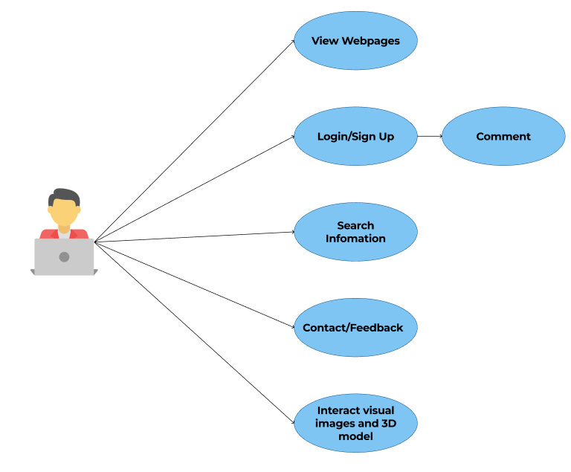

## Use Case Specification

|  |  |  |  |
| --- | --- | --- | --- |
| **USE CASE SPECIFICATION** | | | |
| **Use-case No.** | UC01 | **Use-case Version** | 1.0 |
| **Use-case Name** | *View Webpage* | | |
| **Purpose:**  Users can view information about planets, stars, constellations, dwarf planets, asteroids, and astronomy news such as solar system news, Bigbang theory, Blackhole, space flight, exoplanets, and so on...  **Input:**  **Output:** | | | |

|  |  |  |  |
| --- | --- | --- | --- |
| **USE CASE SPECIFICATION** | | | |
| **Use-case No.** | UC02 | **Use-case Version** | 1.0 |
| **Use-case Name** | *Login/Register* | | |
| **Purpose:**  Users can view information about planets, stars, constellations, dwarf planets, asteroids, and astronomy news such as solar system news, Bigbang theory, Blackhole, space flight, exoplanets, and so on...  **Input:**  Log in to leave a comment on the news post to discuss and learn more information about astronomy with everyone in the world.  Registered users can leave a comment on the news post to discuss and learn more information about astronomy with everyone in the world.  **Output:**  Users used to exit the browser, application. | | | |

|  |  |  |  |
| --- | --- | --- | --- |
| **USE CASE SPECIFICATION** | | | |
| **Use-case No.** | UC03 | **Use-case Version** | 1.0 |
| **Use-case Name** | *Search information* | | |
| **Purpose:**  Users can search for information that they need to learn or read.  **Input:**  The user will enter information key words in a text box provided.  **Output:**  The system will display the news post that matches the search criteria. | | | |

**Site map**

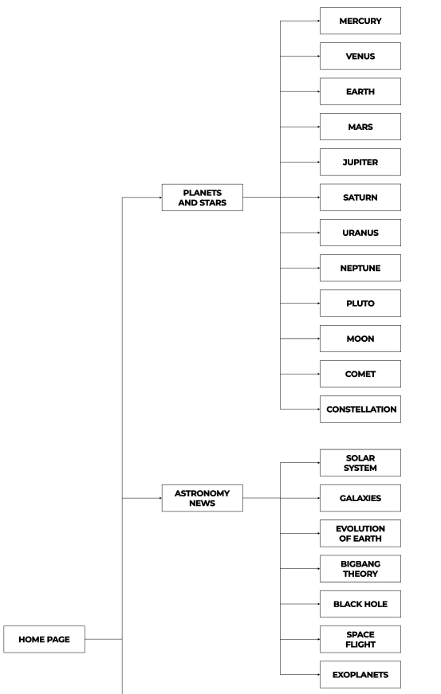

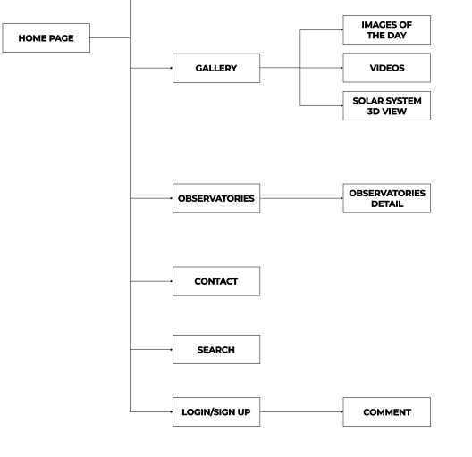

1. **Layout:**

**Layout Home Page**

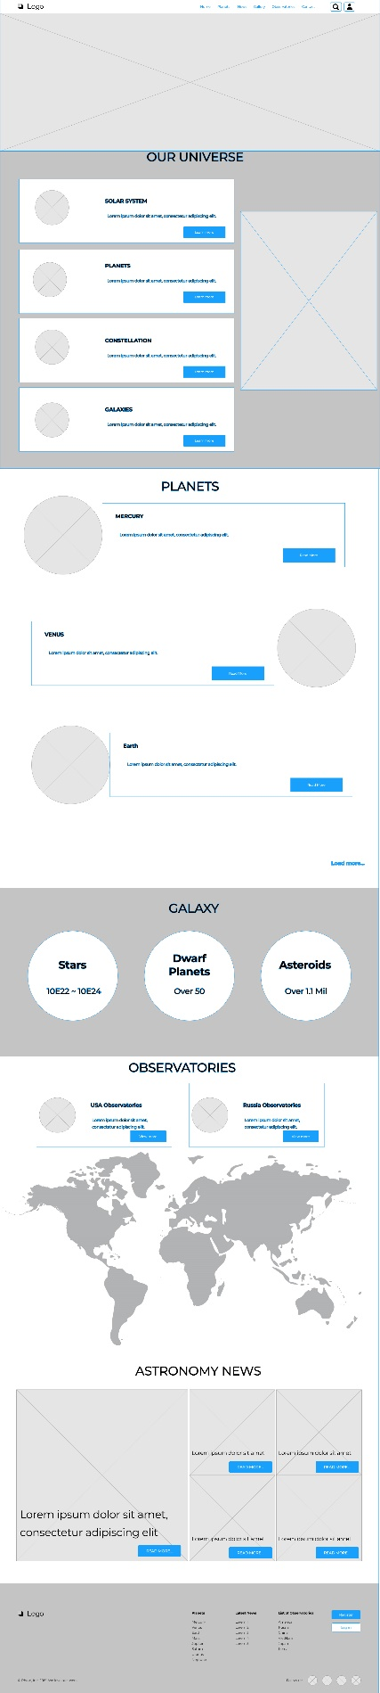

**Layout planets main page**

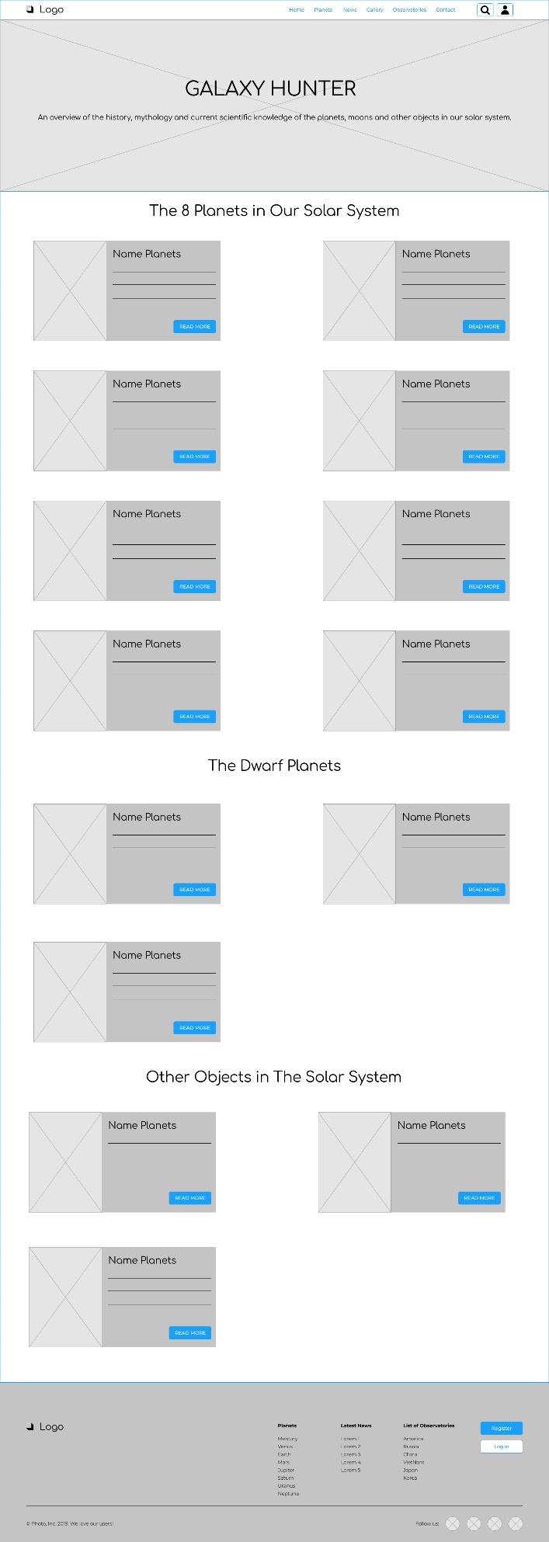

**Layout planet detail page**

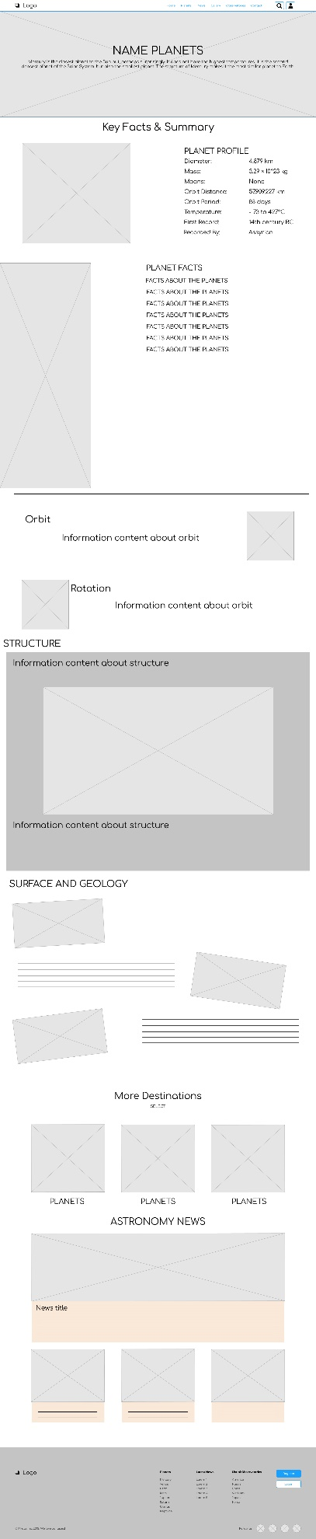

**Layout Observatories**

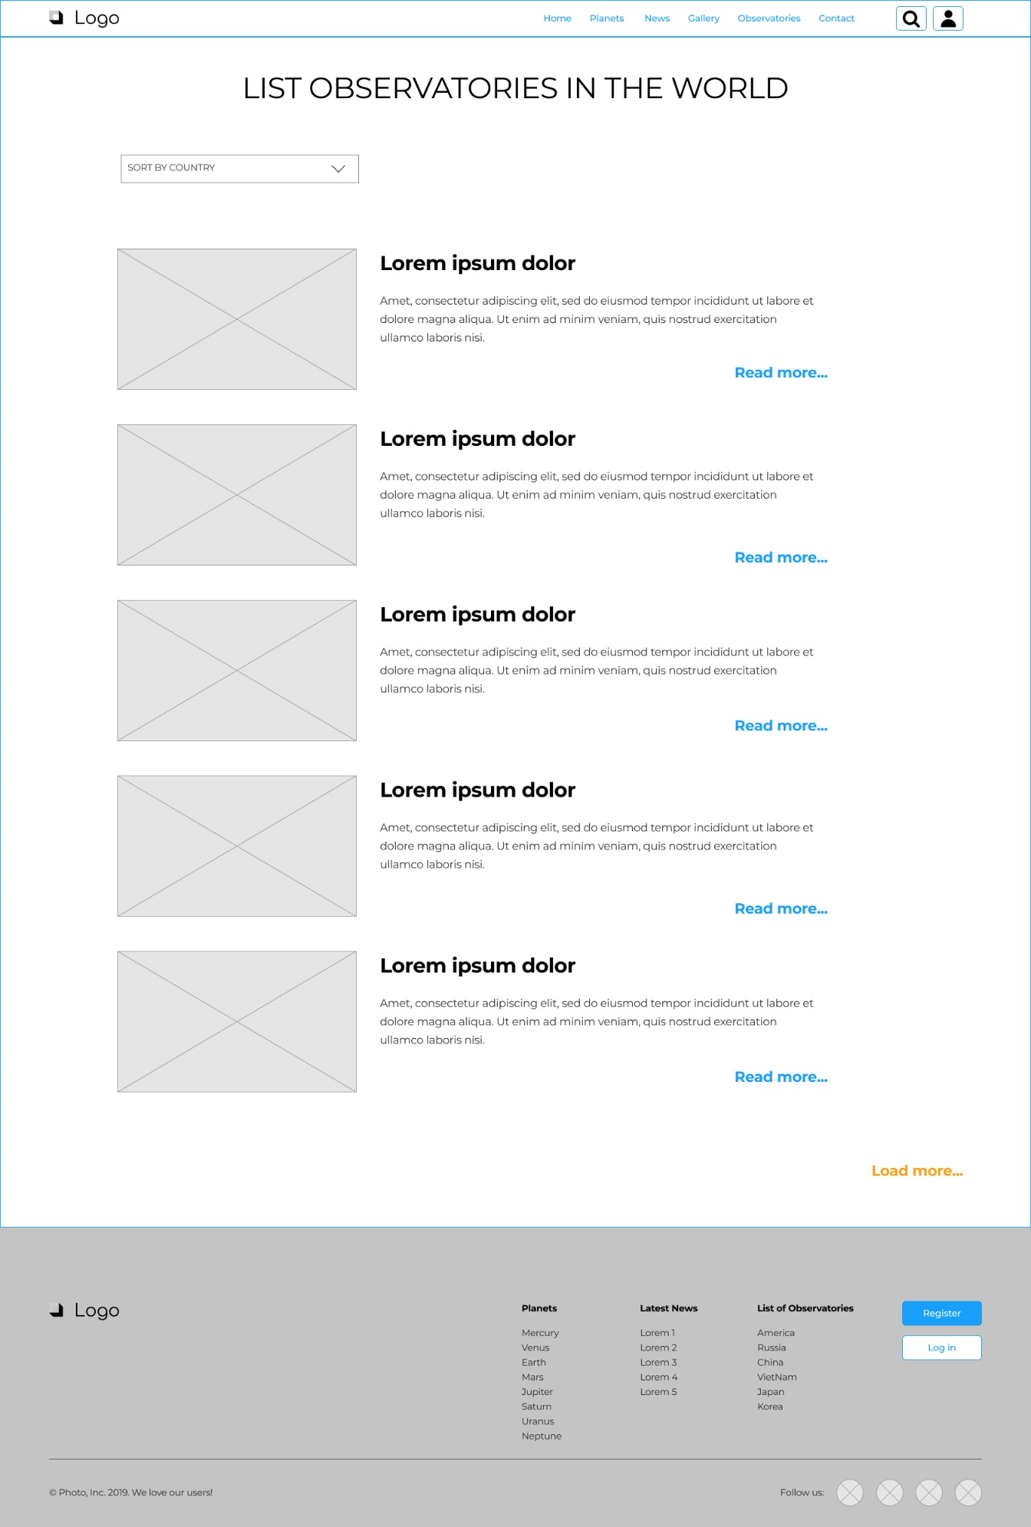

**Layout Observatories detail page**

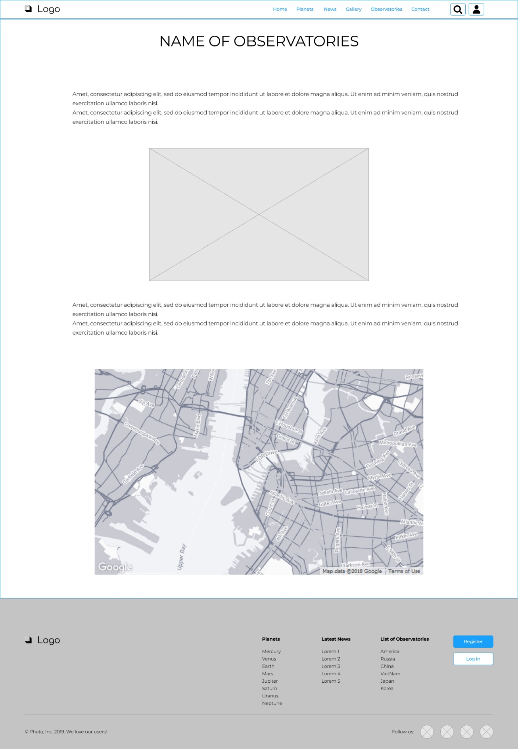

**Login page**

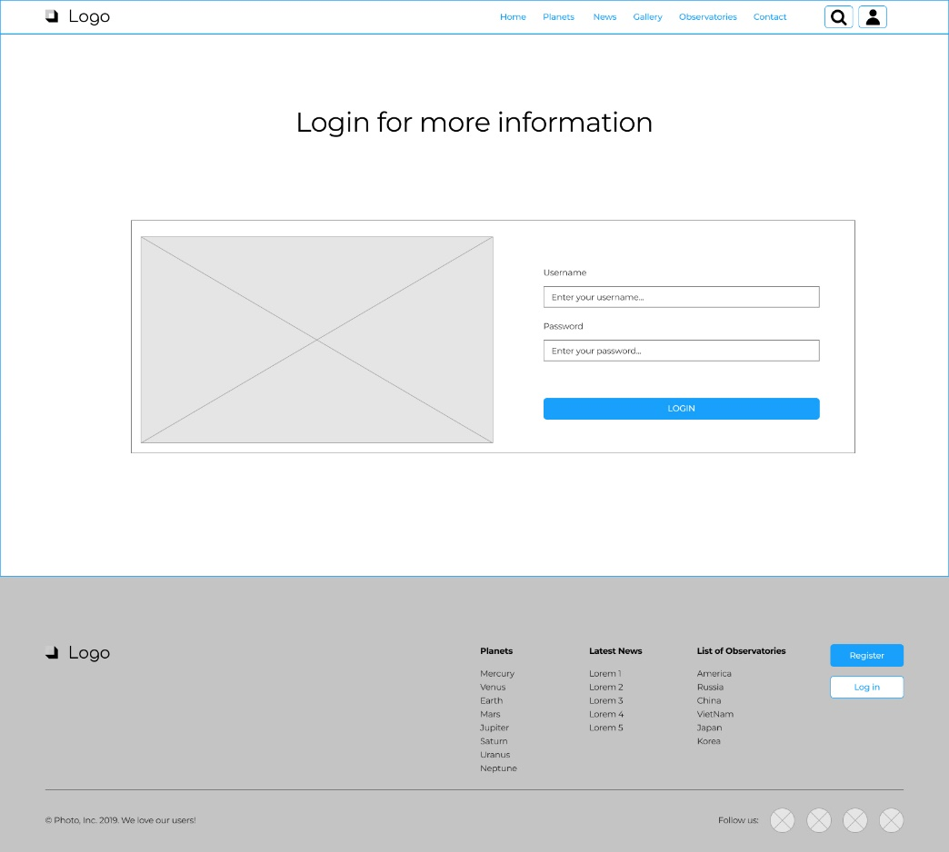

**Sign Up page**

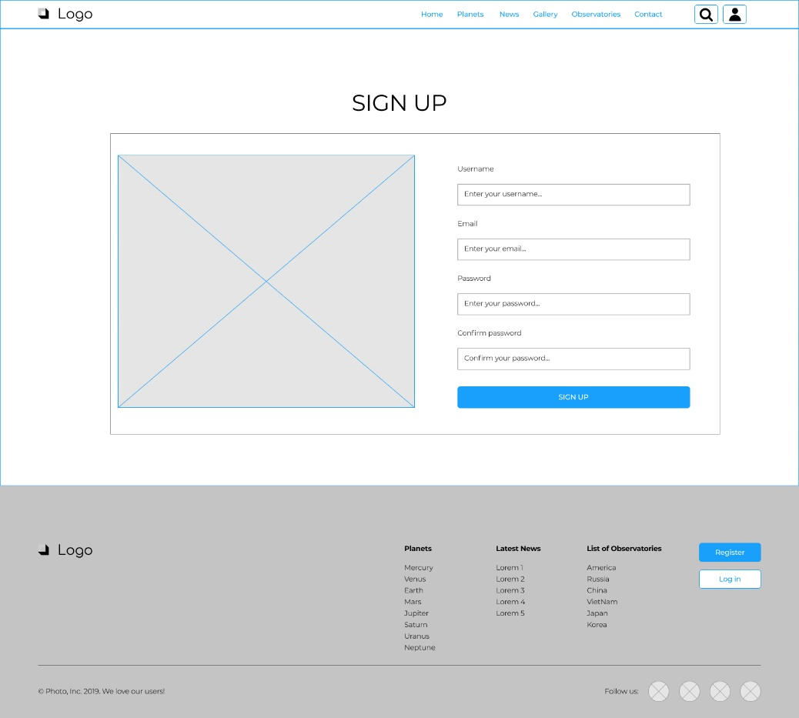

# V. TECHNICAL

Software: Visual Studio Code

Web Browser: Opera, Chrome, Firefox support design Responsive

The technique used to build the Website:

* HTML5 & CSS3.
* Responsive Bootstrap
* Validation for bootstrap.
* JQuery & JavaScript.
* AJAX and JSON
* Local Storage
* Fancybox Jquery
* Lightbox Jquery
* Material for bootstrap:
* JS popover.
* JS Scrollspy.
* Modal.
* Tabs.
* BootStrap Carousel.
* Button.
* Table.
* Form.
* Bootstrap Grid
* …….

# VI. REFERENCES

We consulted information on the websites:

* [**https://jquery.com/**](https://jquery.com/)
* [**http://www.w3schools.com/**](http://www.w3schools.com/)
* [**http://www.getbootstrap.com/**](http://www.getbootstrap.com/)**VII. GUI OF WEBSITE**

**Home page**

**Login page**

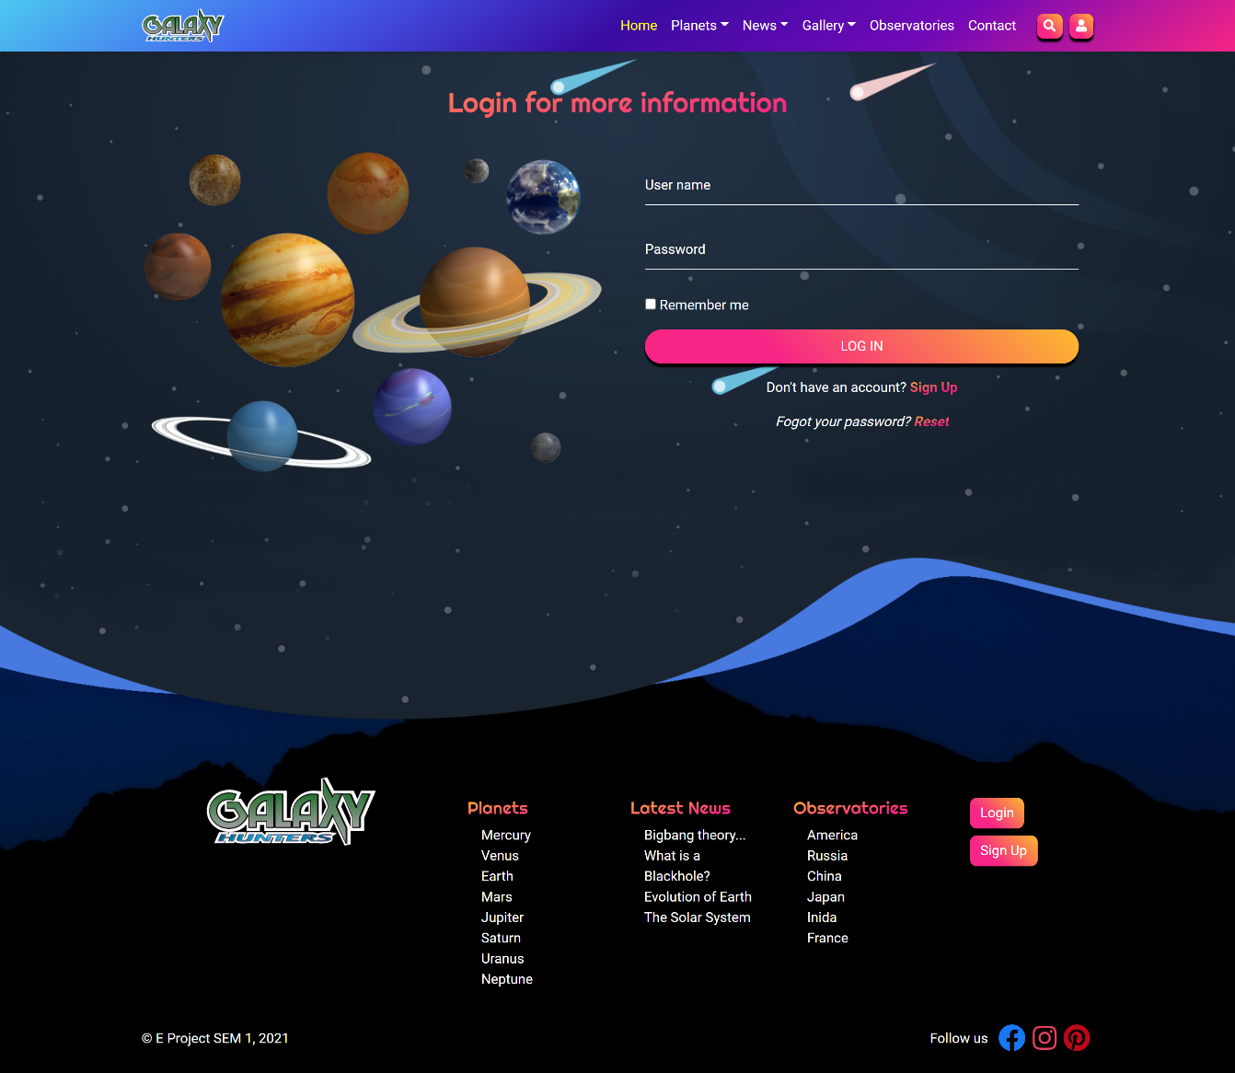

**Sign Up page**

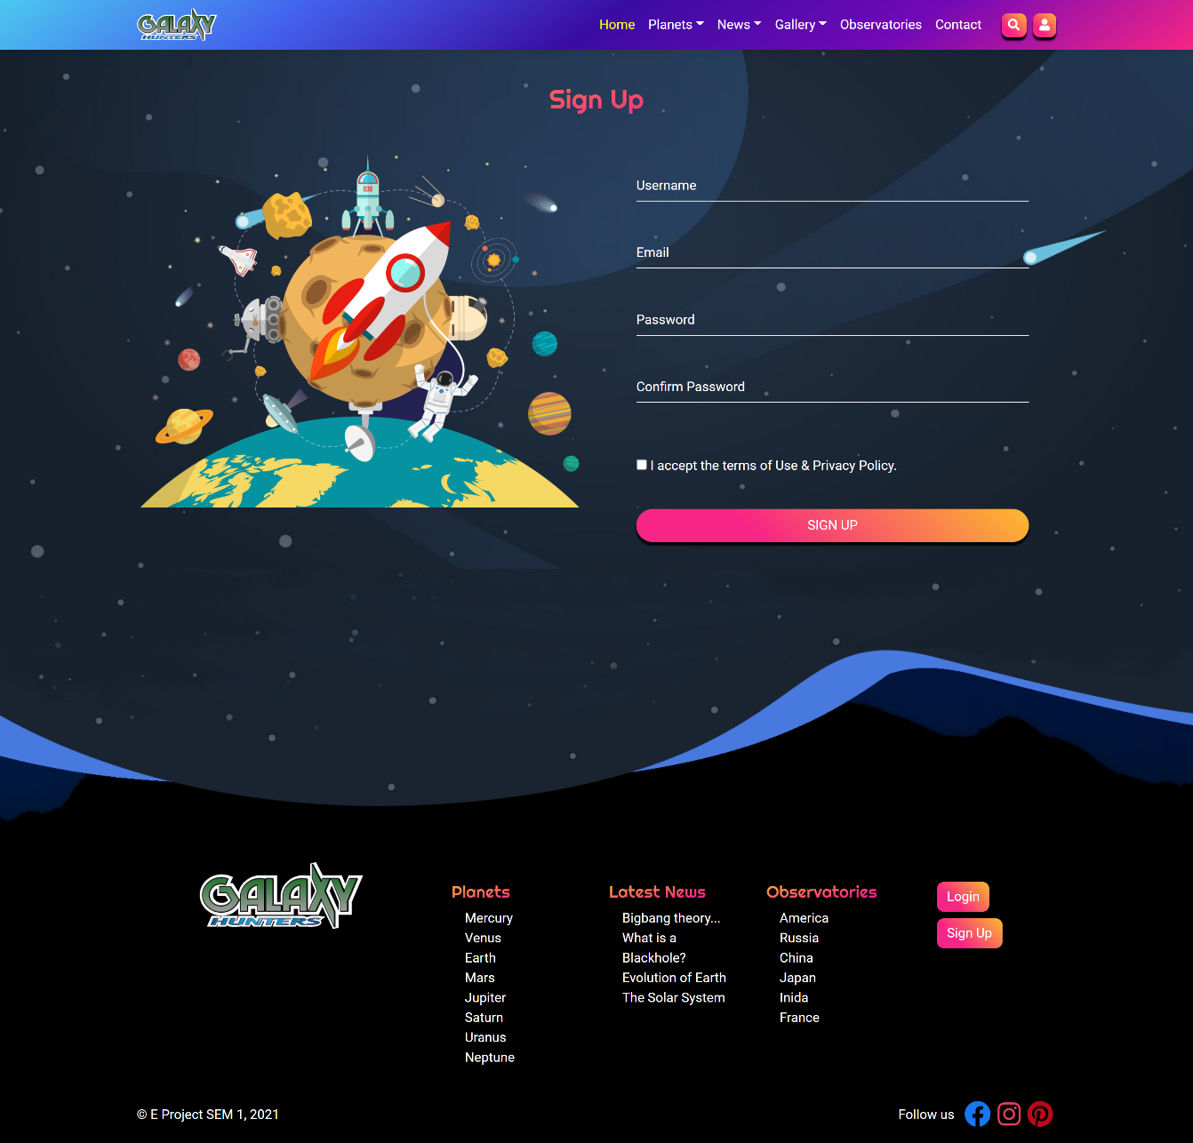

**Planets main page**

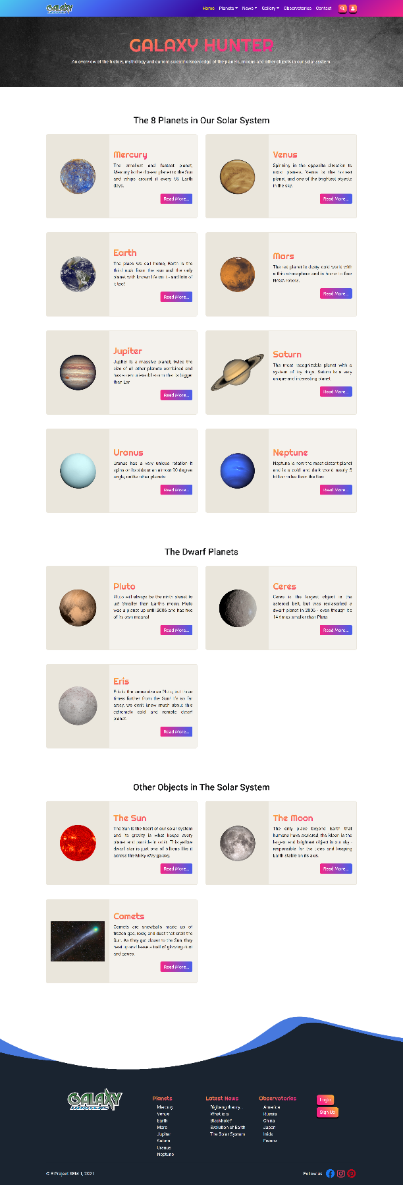

**Planets detail page**

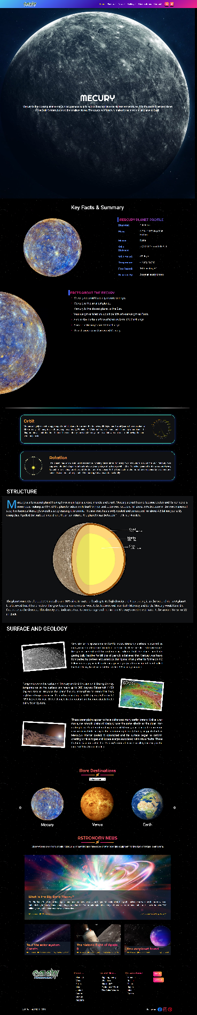

**Observatories main page**

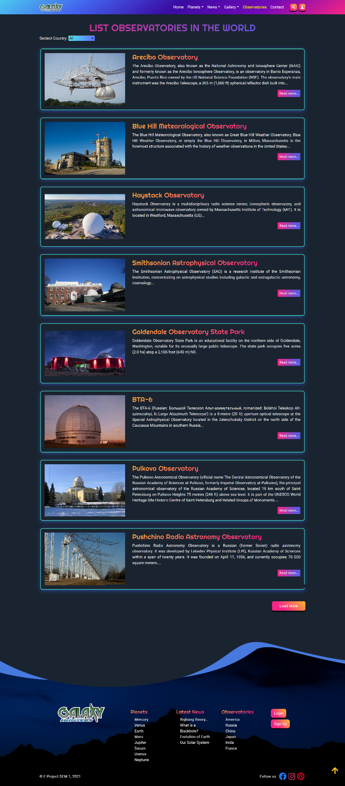

**Observatories detail page**

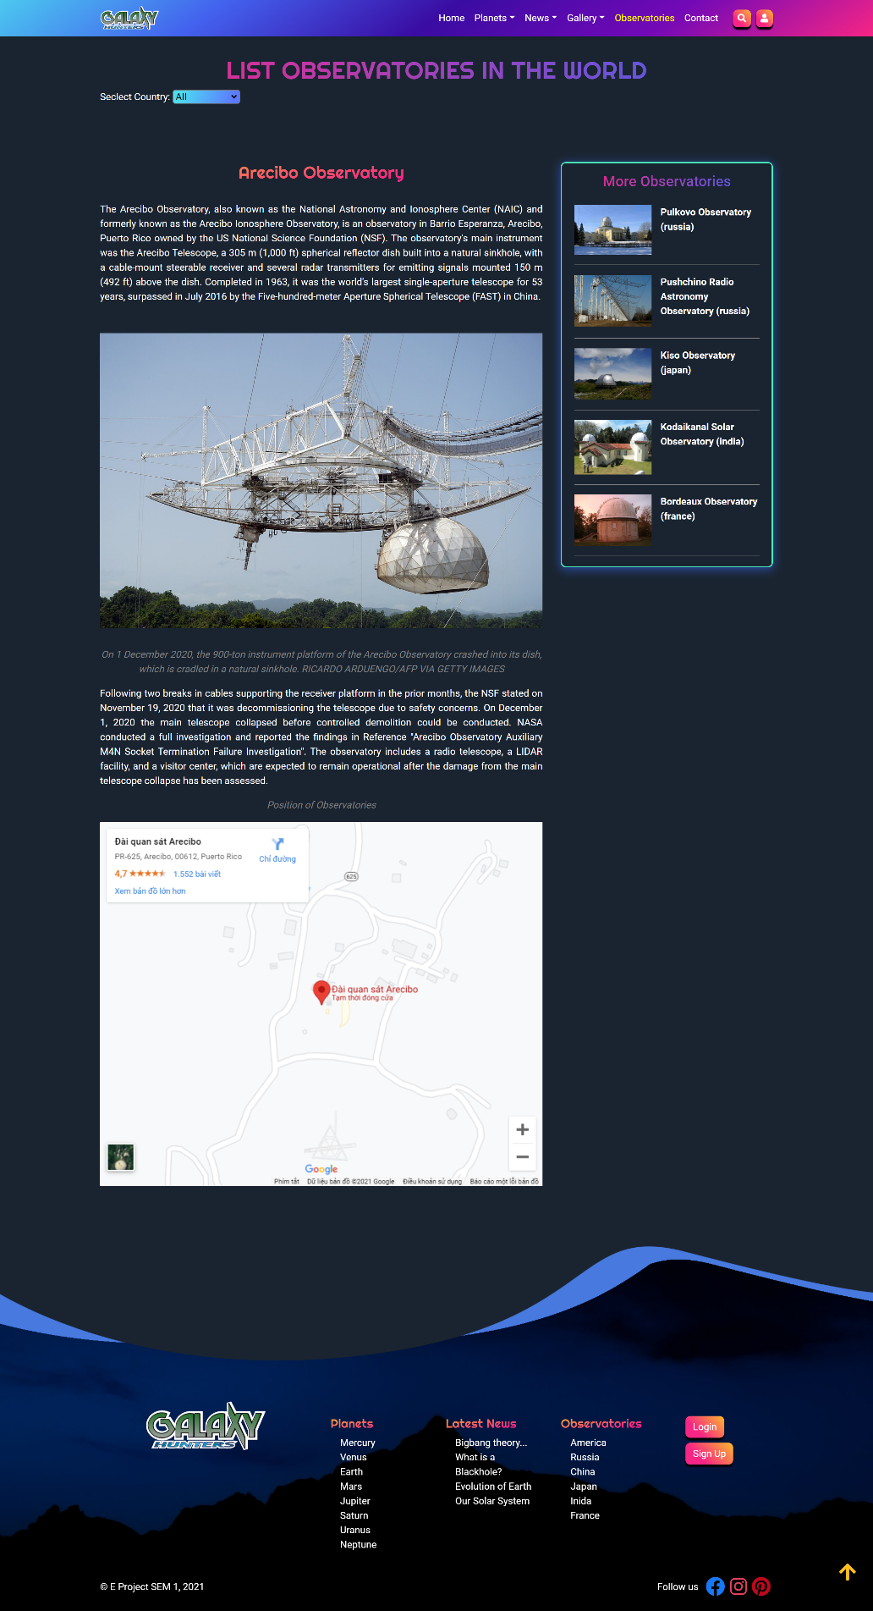

**Search page**

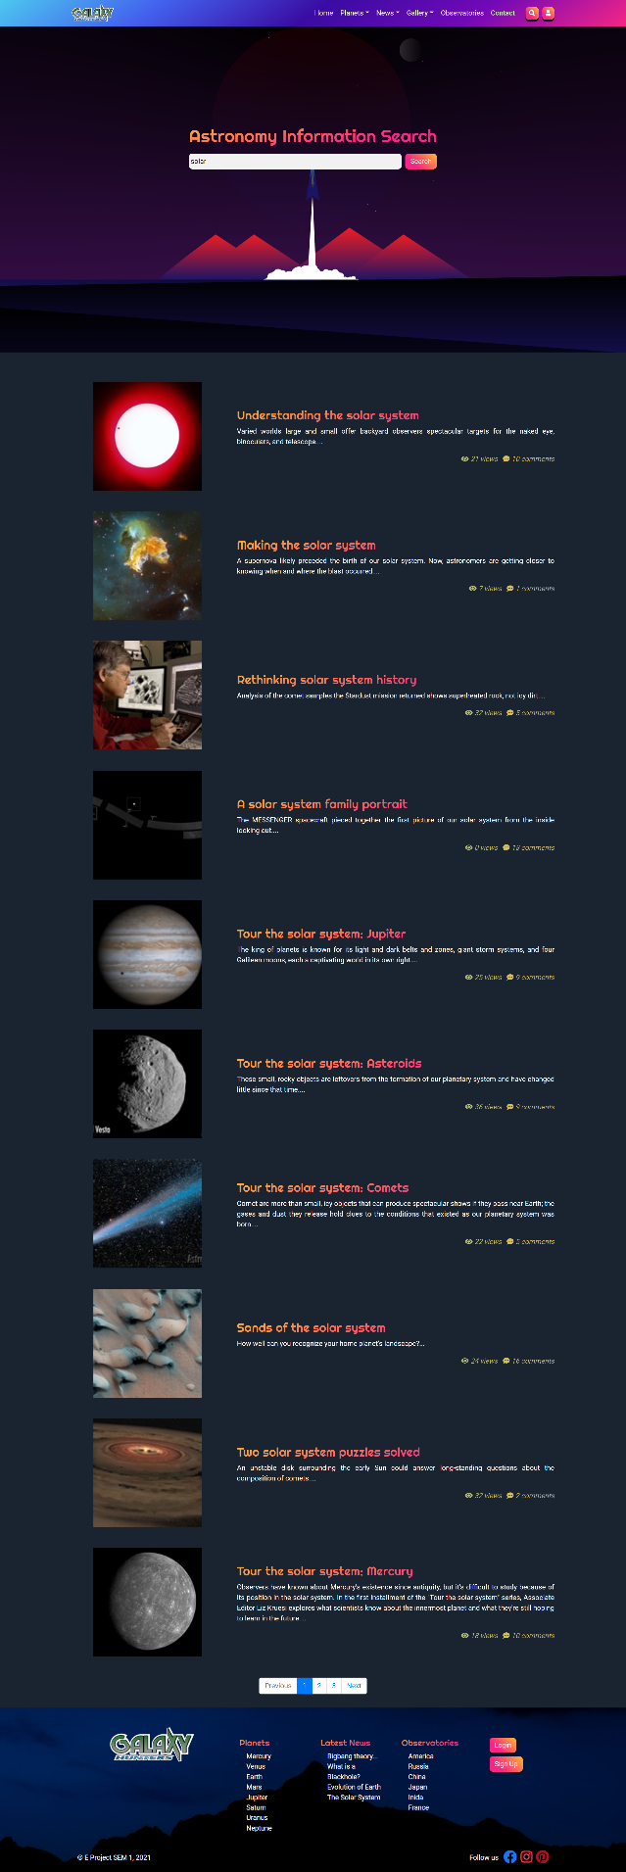

**Gallery images page**

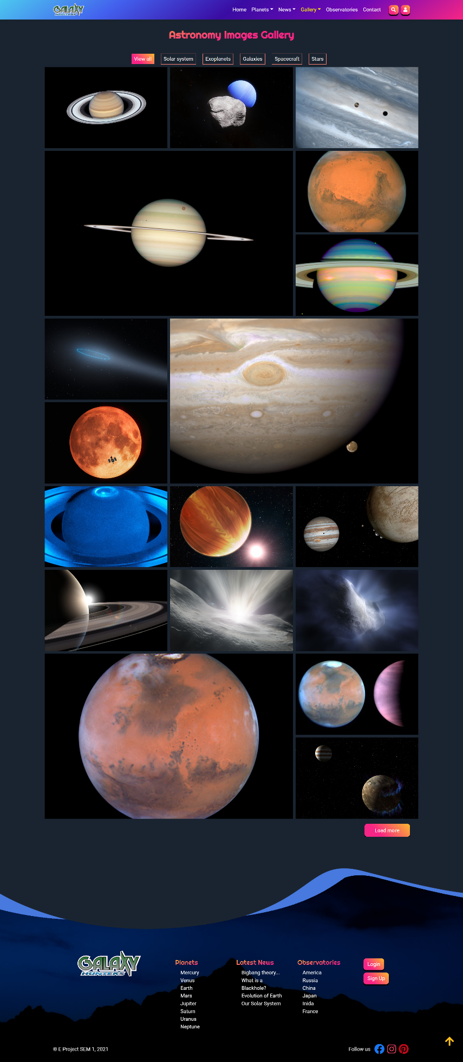

**Gallery videos page**

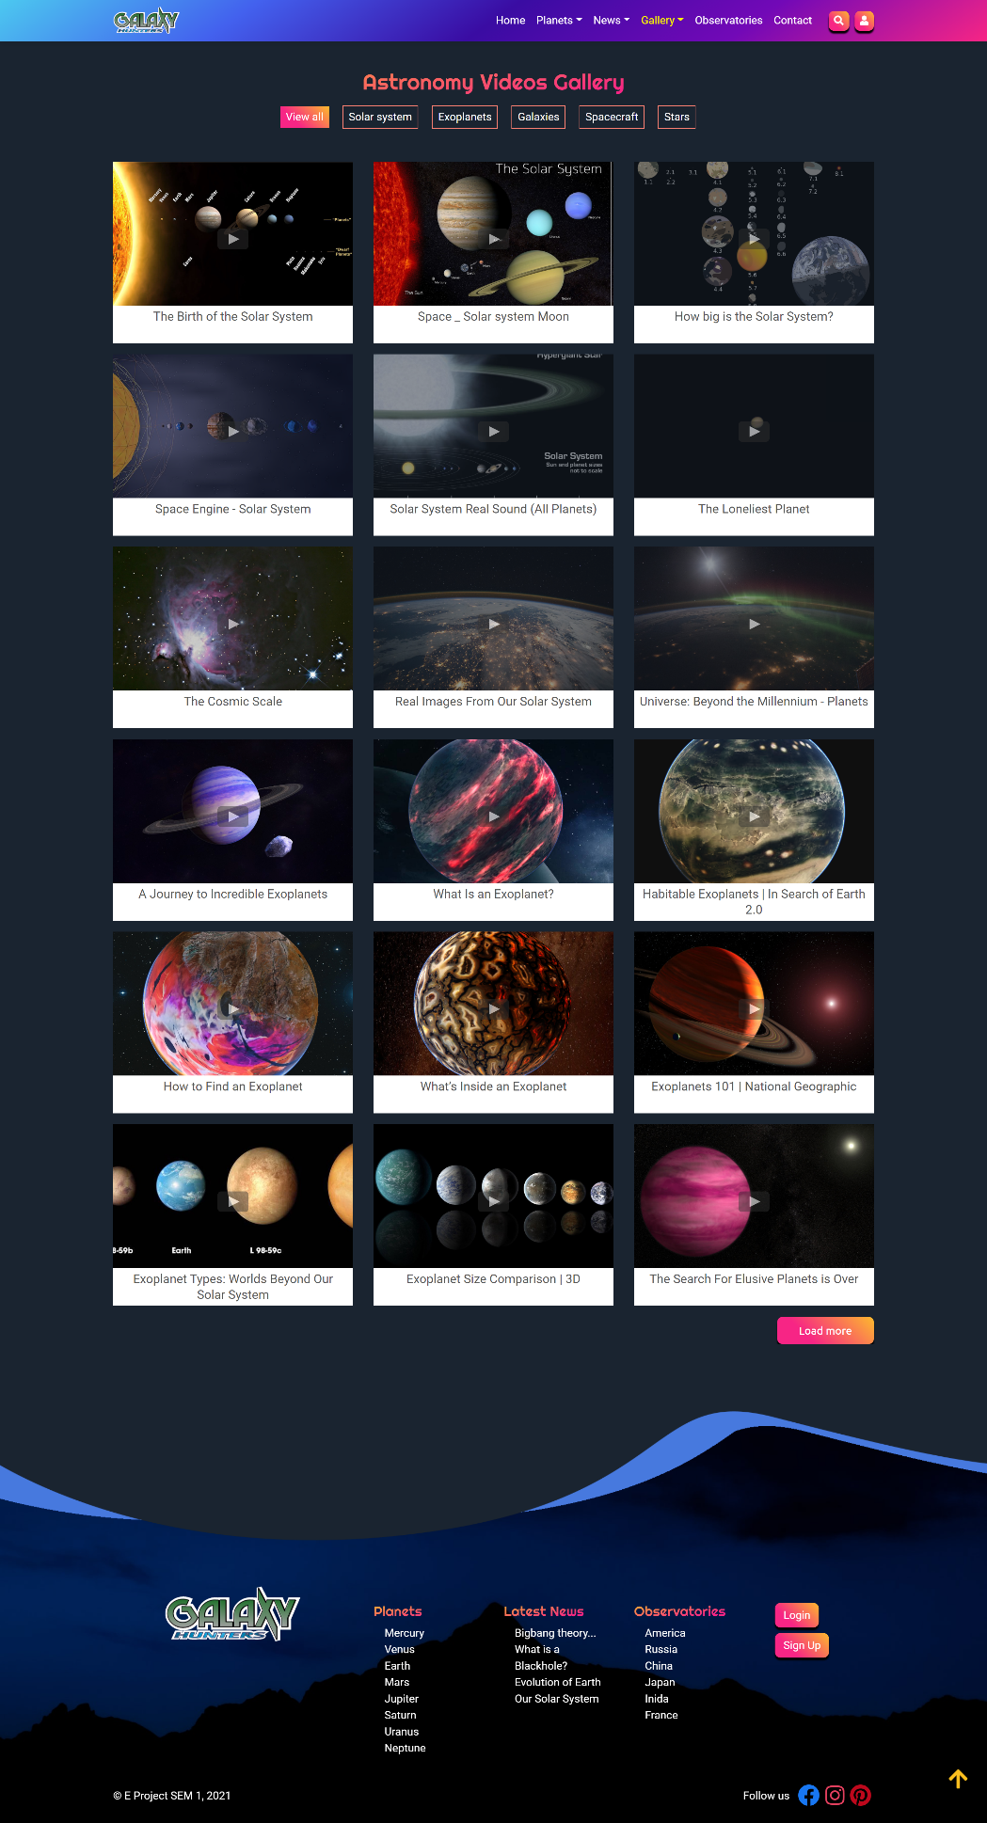

**Gallery 3D solar system page**

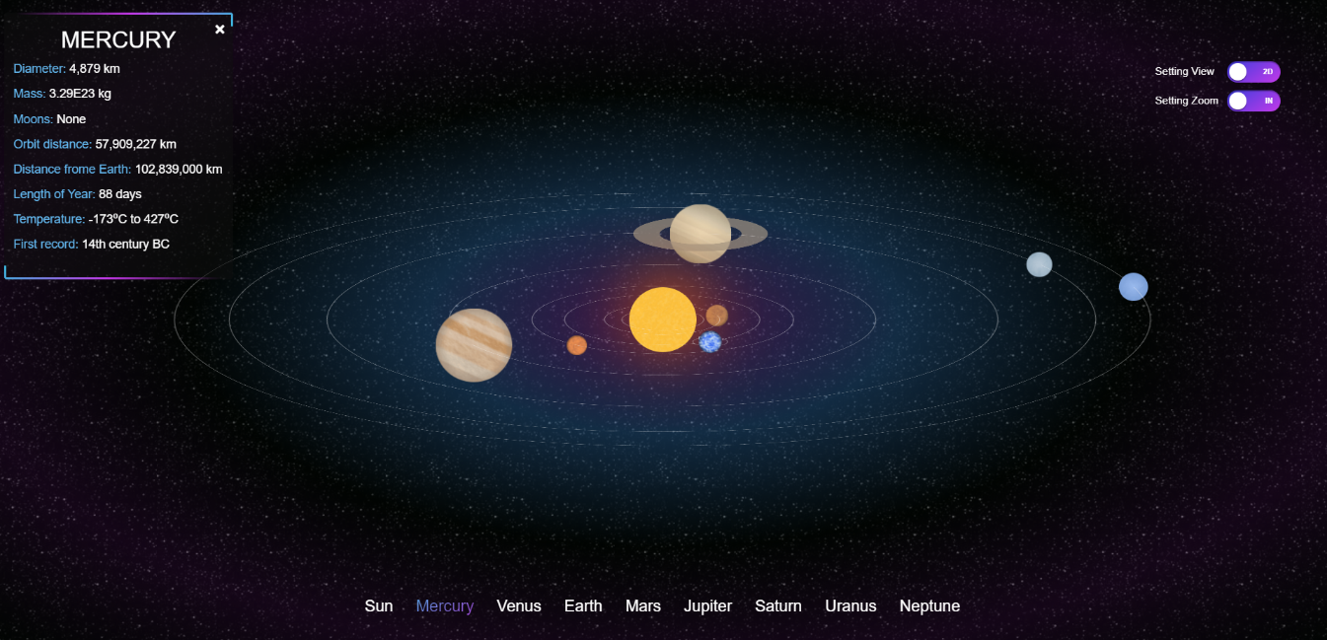

**Contact page**

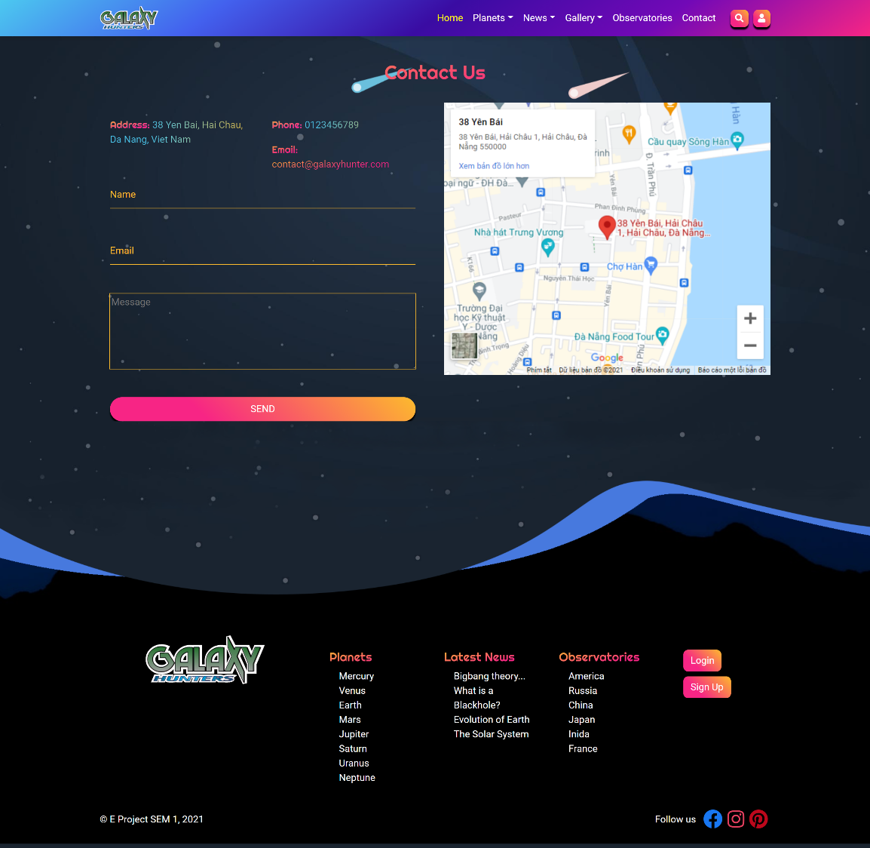

**News page**

# VIII. CHECK LIST

## 1. Check List of Validation

|  |  |
| --- | --- |
| **Option** | **Validate** |
| Fields in forms should not be null | **Yes** |
| Are all the program codes working? | **Yes** |
| The site name for publishing is unique | **Yes** |
| Hyperlinks have tool tip texts | **No** |
| Are there functions for the user to enter their comment | **Yes** |
| Do all the options present in the application display the correct result? | **Yes** |

## 2. Submission Checklist

|  |  |  |  |  |  |
| --- | --- | --- | --- | --- | --- |
| **No.** | **Particulars** | **Yes** | **No** | **N/A** | **Comments** |
| **1** | Do all the web pages open? | **P** |  |  |  |
| **2** | Are all hyperlinks working? | **P** |  |  |  |
| **3** | Are the web page contents devoid of spelling mistakes? | **P** |  |  |  |
| **4** | Are all web components working? | **P** |  |  |  |
| **5** | Is the application user-friendly? | **P** |  |  | Windows GUI is familiar with everyone |

**IX. CONCLUTION**

Galaxy Hunter website includes: Home page, Planets, Observatories, Gallery, News, Search, Contact us, Login/Register.

However, this website also needs to develop and upgrade.

Here is the development direction:

1. Complete or perfect remaing parts of this website
2. Change background image and color, font and other as required by the client
3. Develop mobile-optimized website with functions such as: [Website Responsive](https://www.mypage.vn/thiet-ke-web-theo-chuan-mobile.html), [Responsive Design](https://www.mypage.vn/thiet-ke-web-theo-chuan-mobile.html)…
4. Upgrate static website to dynamic website by using java, C#...
5. Build webApp.

# X. PROJECT PLANNING

|  |  |  |  |
| --- | --- | --- | --- |
| **No.** | **Work** | **Member** | **Status** |
| **1** | Navbar | Dien | Completed |
| **2** | Footer | Dien | Completed |
| **3** | Home page | Dien | Completed |
| **4** | Contact page | Dien | Completed |
| **5** | Login page | Dien | Completed |
| **6** | Sign up page | Dien | Completed |
| **7** | Search page | Dien | Completed |
| **8** | Observatories main page | Dien | Completed |
| **9** | Observatories detail page | Dien | Completed |
| **10** | Solar system 3D view page | Dien | Completed |
| **11** | Planet main page | Thanh | Completed |
| **12** | The Sun page | Thanh | Completed |
| **13** | Mercury page | Thanh | Completed |
| **14** | Venus page | Thanh | Completed |
| **15** | Earth page | Thanh | Completed |
| **16** | Mars page | Thanh | Completed |
| **17** | Jupiter page | Thanh | Completed |
| **18** | Saturn page | Thanh | Completed |
| **19** | Uranus page | Thanh | Completed |
| **20** | Neptune page | Thanh | Completed |
| **21** | Astronomy News main page | An | Completed |
| **22** | Solar system news page | An | Completed |
| **23** | Galaxies news page | An | Completed |
| **24** | Evolution of earth page | An | Completed |
| **25** | Bigbang theory page | An | Completed |
| **26** | Black hole page | An | Completed |
| **27** | Space flight page | An | Completed |
| **28** | Exoplanets page | An | Completed |
| **29** | Gallery image page | Quang | Completed |
| **30** | Gallery video page | Quang | Completed |
| **31** | Pluto page | Quang | Completed |
| **32** | Moon page | Quang | Completed |
| **33** | Comet page | Quang | Completed |
| **34** | Constellation page | Quang | Completed |